Jenkins-04

Jenkins-CICD-Deployment-Complete
1) Setup Jenkins CICD pipeline using freestyle job using Docker containers using below code.
Source Code: https://github.com/betawins/hiring-app.git
Stages:
- Git Clone
- SonarQube Integration
- Maven Compilation
- Nexus Artifactory
- Slack Notification
- Deploy On tomcat

Nexus: wget https://download.sonatype.com/nexus/3/nexus-3.96.4-01-linux-x86_64.tar.gz
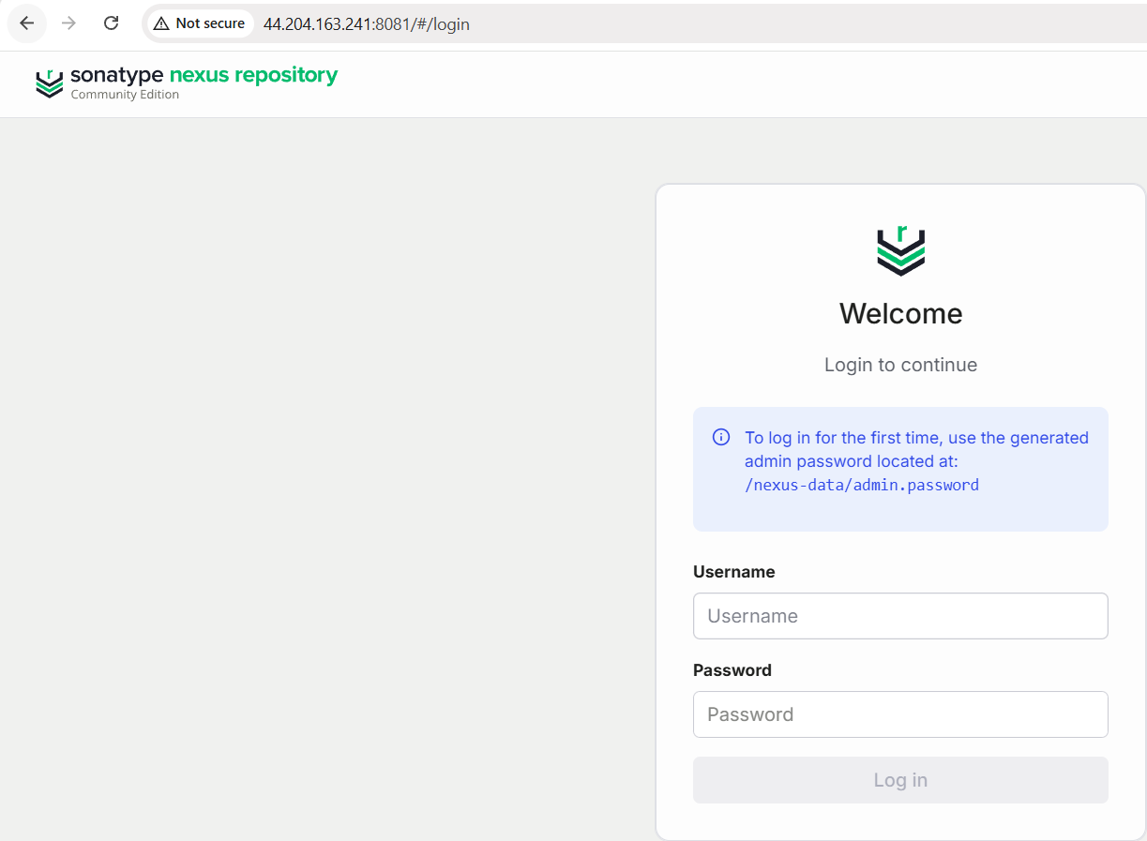
Username : admin
For password run this command : docker exec nexus cat /nexus-data/admin.password
And change the password my my own password
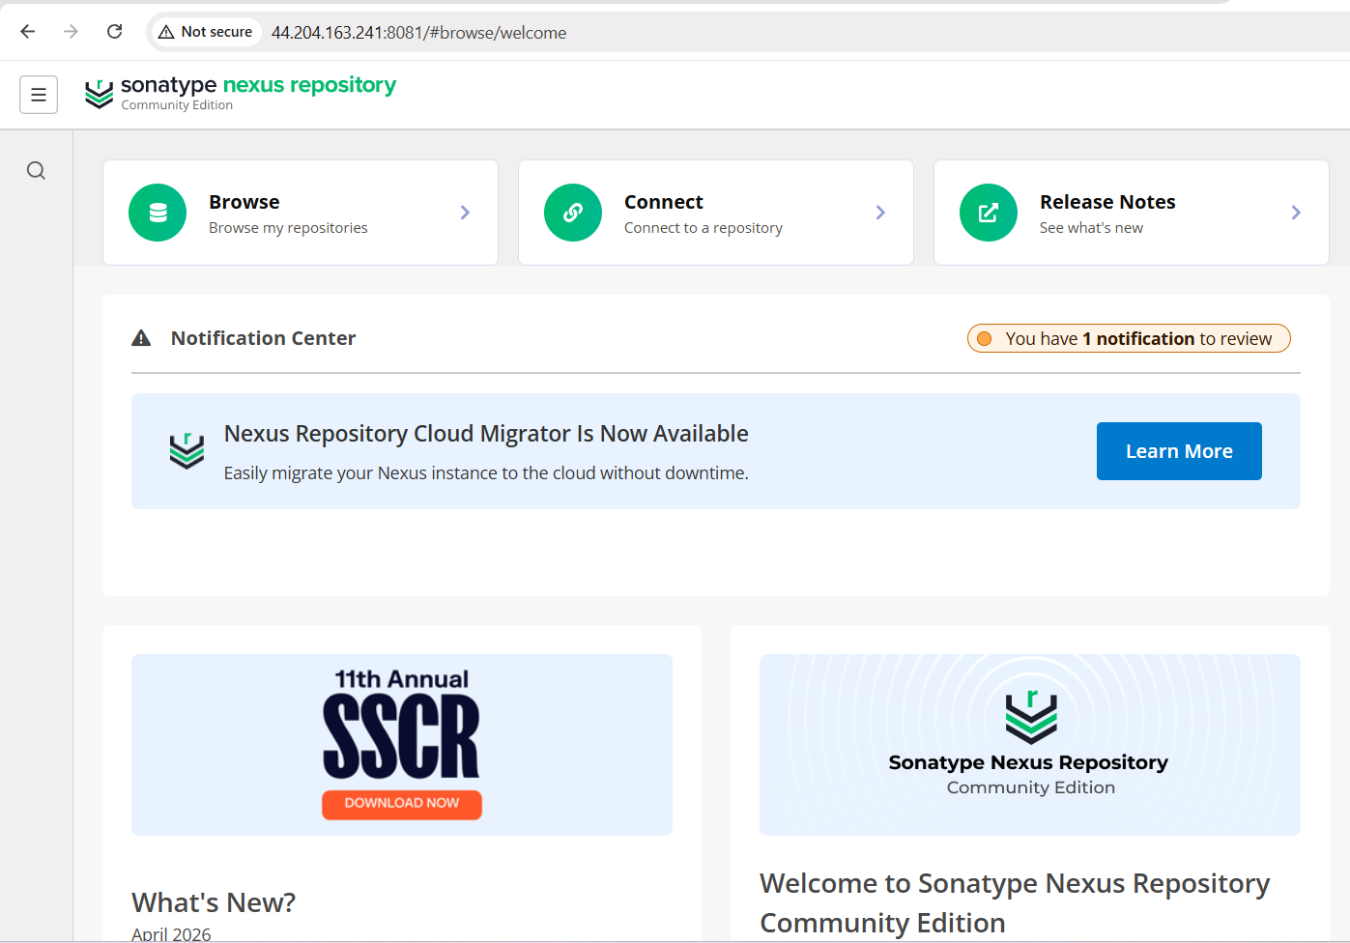
ERROR SS BELOW
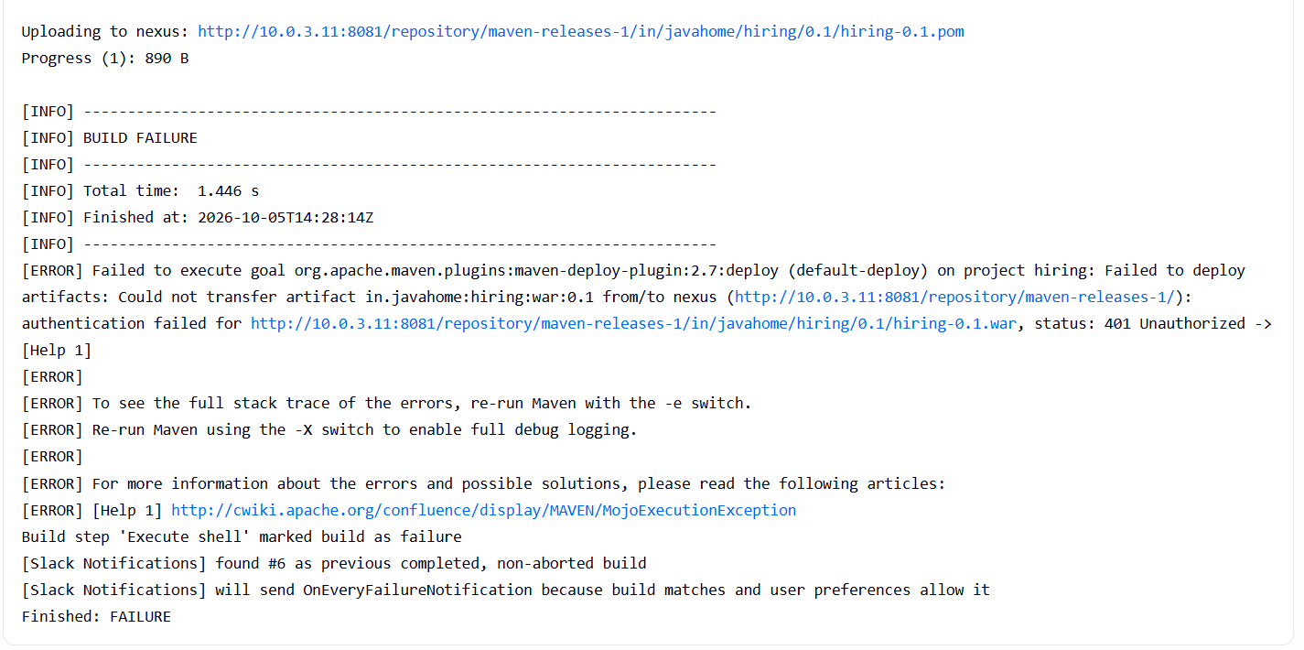
The important fix was creating:
/var/lib/jenkins/.m2/settings.xml

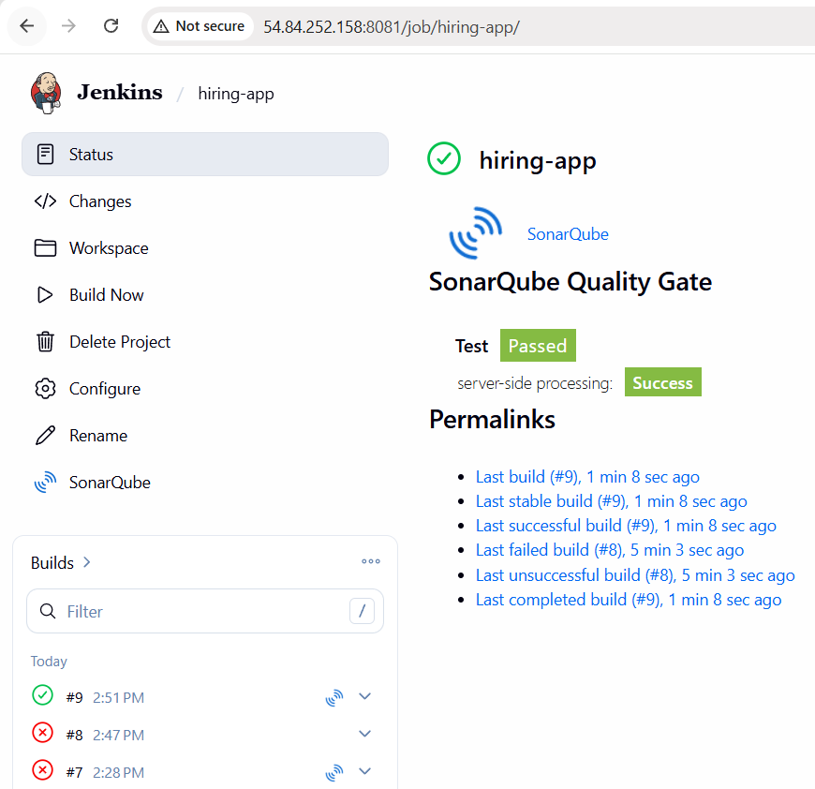
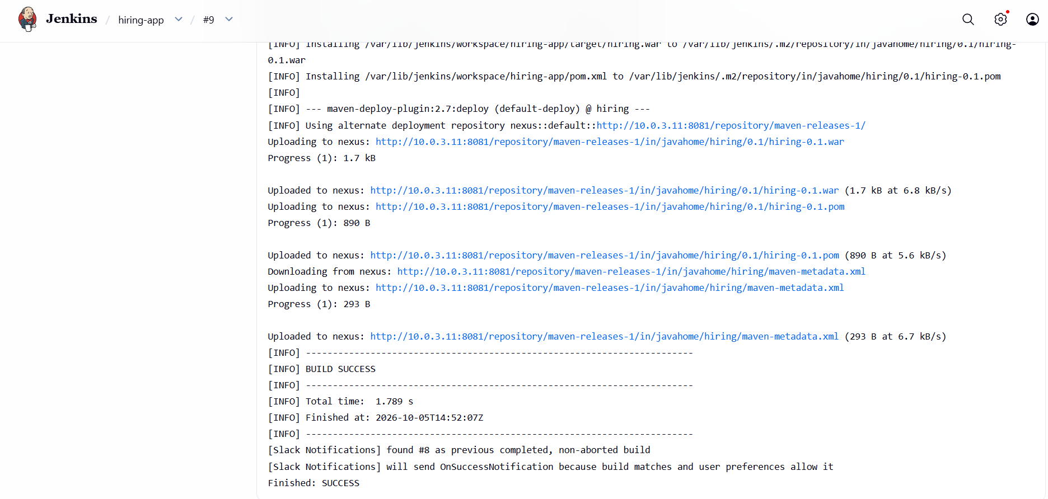
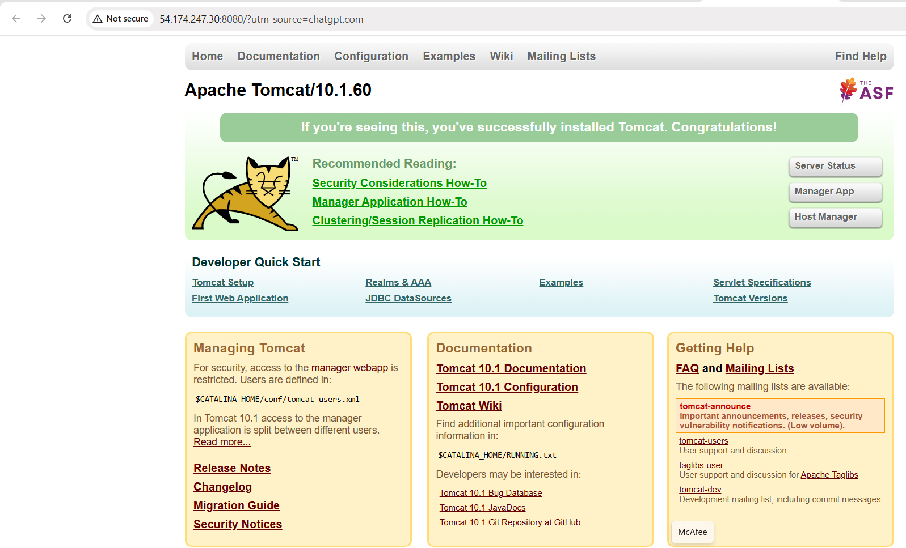
Tomcat is working successfully.
Current setup:
Jenkins → CI/CD pipeline
SonarQube → Code quality
Nexus → Artifact repository
Tomcat → Deployment server ✅

Now we'll connect Jenkins → Tomcat for the final deployment stage.
Step 1 — Configure Tomcat Manager
Tomcat's Manager application is what Jenkins can use to deploy the WAR.
On your Tomcat EC2 SSH terminal, run:
sudo vi /opt/tomcat/conf/tomcat-users.xml
At the bottom, before this line:
</tomcat-users>
add:
<role rolename="manager-gui"/>
<role rolename="manager-script"/>
<user username="jenkins" password="Jenkins@123" roles="manager-gui,manager-script"/>
So the ending should look like:
<tomcat-users>
<role rolename="manager-gui"/>
<role rolename="manager-script"/>
<user username="jenkins" password="Jenkins@123" roles="manager-gui,manager-script"/>
</tomcat-users>
Save in vi
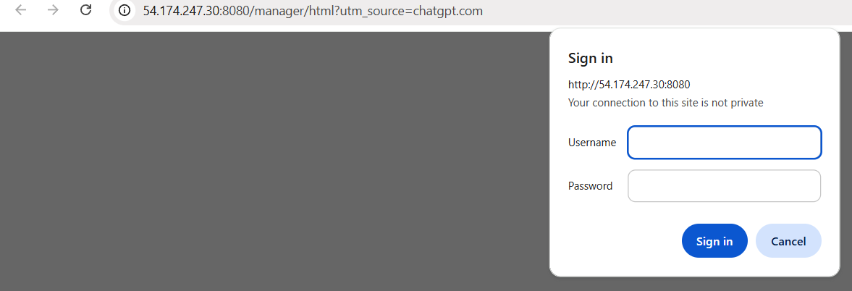
Login:
Username: jenkins
Password: Jenkins@123
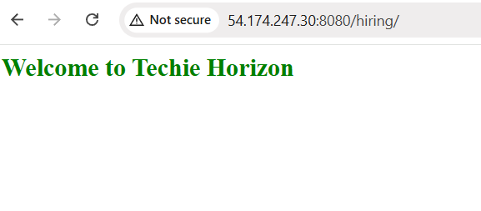
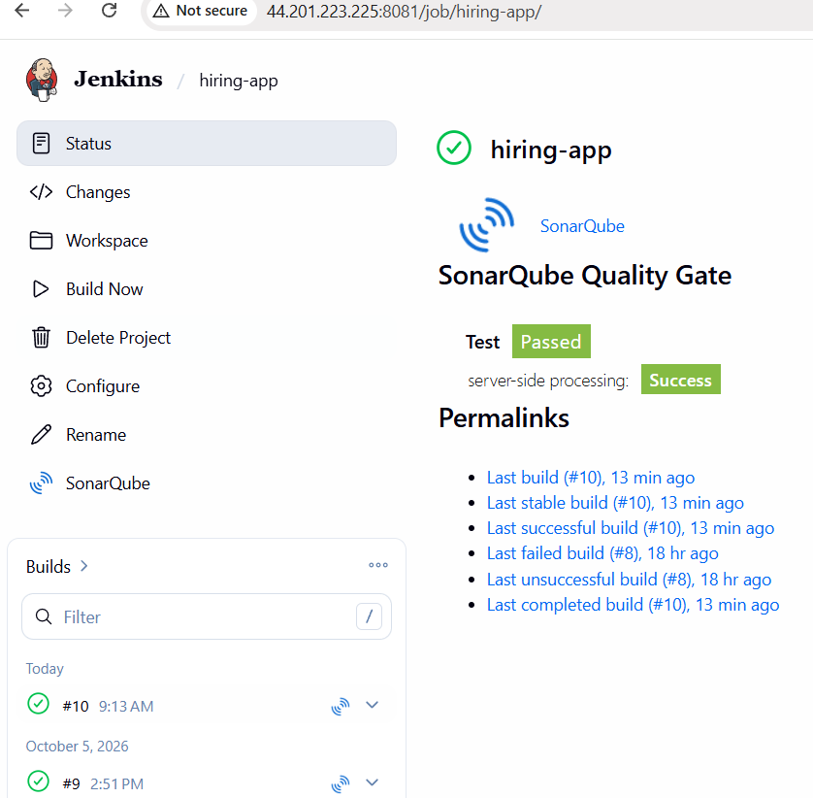
Your final flow is working
GitHub
↓
Jenkins
↓
SonarQube
↓
Maven Build
↓
Nexus
↓
hiring.war
↓
Tomcat
↓
http://54.174.247.30:8080/hiring/
↓
Welcome to Techie Horizon
✅ Final status
CI/CD pipeline: SUCCESSFUL
You have completed:
- ✅ Git Clone
- ✅ SonarQube analysis
- ✅ Maven compilation
- ✅ Nexus artifact upload
- ✅ WAR deployment
- ✅ Tomcat deployment
- ✅ Slack notification
- ✅ Application accessible through browser
The "Welcome to Techie Horizon" page is your deployed application, not the default Tomcat page.
Important distinction
Earlier, the Tomcat root was:
http://54.174.247.30:8080/
That showed the Tomcat Welcome page.
Now you accessed:
http://54.174.247.30:8080/hiring/
and got:
Welcome to Techie Horizon
That confirms the hiring.war application is running on Tomcat.
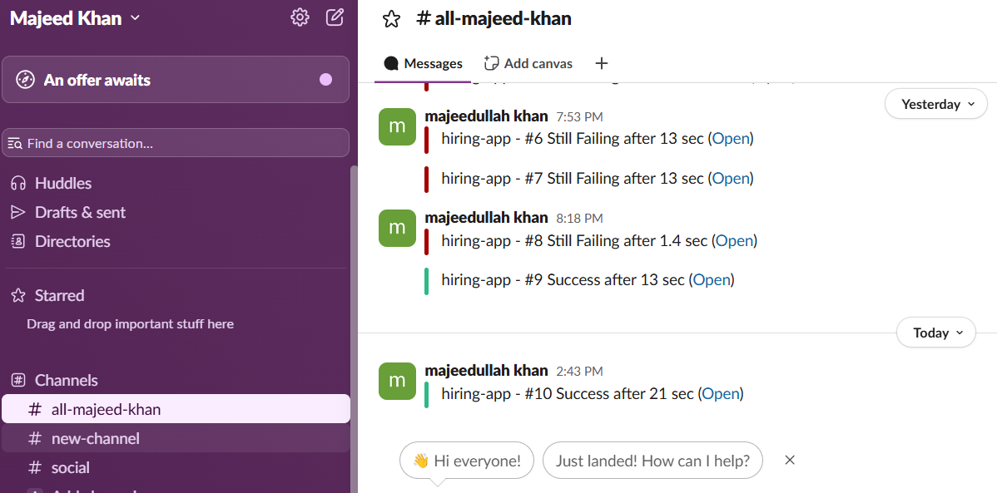
* Jenkins CI/CD Pipeline – Future Reference Notes
1. Project Used
GitHub Repository:
https://github.com/betawins/hiring-app.git
Application:
hiring
Packaging:
WAR
Version:
0.1

2. Complete CI/CD Flow
Developer pushes code
↓
GitHub
↓
Jenkins
↓
SonarQube
↓
Maven
↓
WAR
↓
Nexus
↓
Tomcat
↓
Running Application
↓
Slack
Simple meaning
Component | Purpose
GitHub | Stores application source code
Jenkins | Automates the CI/CD process
SonarQube | Checks code quality
Maven | Builds the Java application
Nexus | Stores the generated artifact/WAR
Tomcat | Runs the WAR application
Slack | Sends build notifications

3. Jenkins Job
Jenkins job name:
hiring-app
The job is a Freestyle Project.
The pipeline stages configured were:
1. Git Clone
2. SonarQube Integration
3. Maven Compilation
4. Nexus Artifactory
5. Slack Notification
6. Deploy on Tomcat

4. Maven Build
The application uses Maven.
The important Maven command was:
mvn clean package
Maven creates the WAR file inside:
target/
The generated WAR was:
target/hiring.war
This WAR file is what Jenkins deploys to Tomcat.

5. SonarQube
SonarQube is used to perform code quality analysis.
Jenkins sends the project to SonarQube during the build.
Example SonarQube URL used during the lab:
http://<SONARQUBE-IP>:9000
Important:
If the SonarQube EC2 is stopped and started again, its public IP may change.
Therefore, update the Jenkins SonarQube configuration if necessary.

6. Nexus
Nexus is used as the artifact repository.
The Nexus repository used:
maven-releases-1
Example repository URL:
http://10.0.3.11:8081/repository/maven-releases-1/
During the successful build Jenkins showed:
Uploading to nexus
and:
Uploaded to nexus:
.../in/javahome/hiring/maven-metadata.xml
This confirmed that Maven successfully uploaded the artifact information to Nexus.
Important
Nexus was running as a Docker container:
sonatype/nexus3
Container name:
nexus

7. Tomcat Server
Tomcat EC2:
Name: Tomcat-Server
Instance type: t3.small
OS: Amazon Linux 2023
Private IP: 10.0.3.65
Public IP: 54.174.247.30
Tomcat version:
Apache Tomcat 10.1.60
Java:
Java 17
Tomcat installation directory:
/opt/tomcat
Tomcat URL:
http://54.174.247.30:8080

8. Starting and Stopping Tomcat
Start Tomcat:
/opt/tomcat/bin/startup.sh
Stop Tomcat:
/opt/tomcat/bin/shutdown.sh
Restart Tomcat:
/opt/tomcat/bin/shutdown.sh
sleep 5
/opt/tomcat/bin/startup.sh

9. Tomcat Manager
Tomcat Manager was required so Jenkins could deploy the WAR automatically.
Manager URL:
http://54.174.247.30:8080/manager/html
Jenkins deployment username:
jenkins
The password was configured in Tomcat and stored securely in Jenkins credentials.
Tomcat roles:
<role rolename="manager-gui"/>
<role rolename="manager-script"/>
The Jenkins user was configured with:
<user username="jenkins"
password="Jenkins@123"
roles="manager-gui,manager-script"/>
Important
manager-script is important because Jenkins uses the Tomcat Manager interface to deploy the WAR.

10. Testing Tomcat Manager
A very useful test command:
curl -u jenkins:'Jenkins@123' http://localhost:8080/manager/text/list
Successful output looked like:
OK - Listed applications for virtual host [localhost]
/:running:0:ROOT
/examples:running:0:examples
/host-manager:running:0:host-manager
/manager:running:0:manager
/docs:running:0:docs
This proves:
Tomcat
↓
Tomcat Manager
↓
jenkins user
↓
manager-script
are working.

11. Jenkins Credentials
Jenkins credentials were created under:
Manage Jenkins
→ Credentials
→ System
→ Global credentials
Credential:
ID:
tomcat-credentials
Username:
jenkins
The password is stored inside Jenkins credentials and should NOT be written directly into the Jenkins job configuration.

12. Deploy WAR to Tomcat
Jenkins job:
hiring-app
Go to:
Configure
→ Post-build Actions
→ Deploy war/ear to a container
Configuration:
WAR/EAR files:
target/*.war
Context path:
(empty)
Container:
Tomcat 9.x Remote
Credentials:
jenkins / Tomcat Server Credentials
Tomcat URL:
http://54.174.247.30:8080
Advanced options:
Default

13. Why Tomcat 9.x Remote Was Selected
The Jenkins plugin displayed:
Tomcat 9.x Remote
even though the server is running:
Tomcat 10.1.60
For this lab, deployment succeeded using that Jenkins plugin option.
Therefore, don't change it if the current deployment is working.

14. Successful Jenkins Deployment Log
Important successful messages were:
[DeployPublisher][INFO] Attempting to deploy 1 war file(s)
Then:
Deploying .../target/hiring.war
Then:
Finished: SUCCESS
This means Jenkins successfully deployed the WAR.

15. Verify the Application
After deployment, open:
http://54.174.247.30:8080/hiring/
The successful result was:
Welcome to Techie Horizon
This confirms that the actual application is running on Tomcat.
Don't confuse this with:
http://54.174.247.30:8080/
The root URL can show the default Tomcat page.
The application is under:
/hiring/

16. How to Understand the Whole Process
Think of it like this:
GitHub
Source code
↓
GitHub
Jenkins
Jenkins downloads source code
SonarQube
Jenkins
↓
SonarQube
↓
Code quality analysis
Maven
Source code
↓
Maven
↓
hiring.war
Nexus
hiring.war
↓
Nexus
↓
Artifact Repository
Tomcat
hiring.war
↓
Tomcat
↓
Web Application
Final result
Browser
↓
http://54.174.247.30:8080/hiring/
↓
Welcome to Techie Horizon

17. Most Important Files/Paths
Jenkins workspace
/var/lib/jenkins/workspace/hiring-app/
Generated WAR
/var/lib/jenkins/workspace/hiring-app/target/hiring.war
Tomcat installation
/opt/tomcat/
Tomcat configuration
/opt/tomcat/conf/
Tomcat users
/opt/tomcat/conf/tomcat-users.xml
Tomcat Manager configuration
/opt/tomcat/webapps/manager/META-INF/context.xml
Tomcat logs
/opt/tomcat/logs/
Main log:
/opt/tomcat/logs/catalina.out

18. Useful Troubleshooting Commands
Check Java
java -version
Check Tomcat process
ps -ef | grep tomcat
Check port 8080
sudo ss -lntp | grep 8080
Check Tomcat log
tail -f /opt/tomcat/logs/catalina.out
Test Manager
curl -u jenkins:'Jenkins@123' http://localhost:8080/manager/text/list
Restart Tomcat
/opt/tomcat/bin/shutdown.sh
sleep 5
/opt/tomcat/bin/startup.sh

19. Common Problems
Problem 1 — Jenkins cannot deploy to Tomcat
Check:
Tomcat port 8080
Tomcat Manager
Jenkins credentials
Security Group
Tomcat URL

Problem 2 — 401 Unauthorized
Usually means:
Username/password incorrect
or Tomcat Manager roles are missing.
Check:
manager-script

Problem 3 — 403 Forbidden
Check the Tomcat Manager context.xml.
The Manager application can restrict remote access using a RemoteCIDRValve.

Problem 4 — Tomcat Manager doesn't accept login
Check:
/opt/tomcat/conf/tomcat-users.xml
Make sure the XML is valid.
A malformed XML file caused a problem during our setup.

Problem 5 — Jenkins deployment succeeds but application gives 404
Check the deployed context:
http://<Tomcat-IP>:8080/hiring/
Also check Tomcat Manager to see whether /hiring is listed.

20. Important AWS Reminder
EC2 public IP addresses can change when an instance is stopped and started.
For example:
Old Tomcat IP:
54.174.247.30
If the EC2 is stopped and started later, the IP may become different.
Then update:
Jenkins Tomcat URL
For example:
http://NEW-IP:8080
Similarly, SonarQube and Nexus public IPs can change if they don't use Elastic IPs.

21. Final Verification Checklist
Before considering the lab complete:
[✓] GitHub repository accessible
[✓] Jenkins job created
[✓] Git clone successful
[✓] SonarQube analysis successful
[✓] Maven build successful
[✓] WAR generated
[✓] Nexus upload successful
[✓] Slack notification successful
[✓] Tomcat installed
[✓] Tomcat Manager configured
[✓] Jenkins Tomcat credentials created
[✓] Jenkins Deploy to Container plugin installed
[✓] WAR deployed to Tomcat
[✓] Application accessible
[✓] "Welcome to Techie Horizon" displayed
Final Result
CI/CD PIPELINE

GitHub
│
▼
Jenkins
│
├────► SonarQube
│
▼
Maven
│
▼
hiring.war
│
├────► Nexus
│
▼
Tomcat
│
▼
http://<Tomcat-IP>:8080/hiring/
│
▼
Welcome to Techie Horizon
This is the main concept to remember: Jenkins is the automation/orchestrator. Maven creates the WAR, Nexus stores the artifact, and Tomcat runs the WAR.

2) Setup a Jenkins CICD pipeline using Declarative pipeline using feature-1.1 branch.
Source Code: https://github.com/betawins/sabear_simplecutomerapp/tree/feature-1.1
stages:
- Git Clone
- SonarQube Integration
- Maven Compilation
- Nexus Artifactory
- Slack Notification
- Deploy On tomcat
Error:
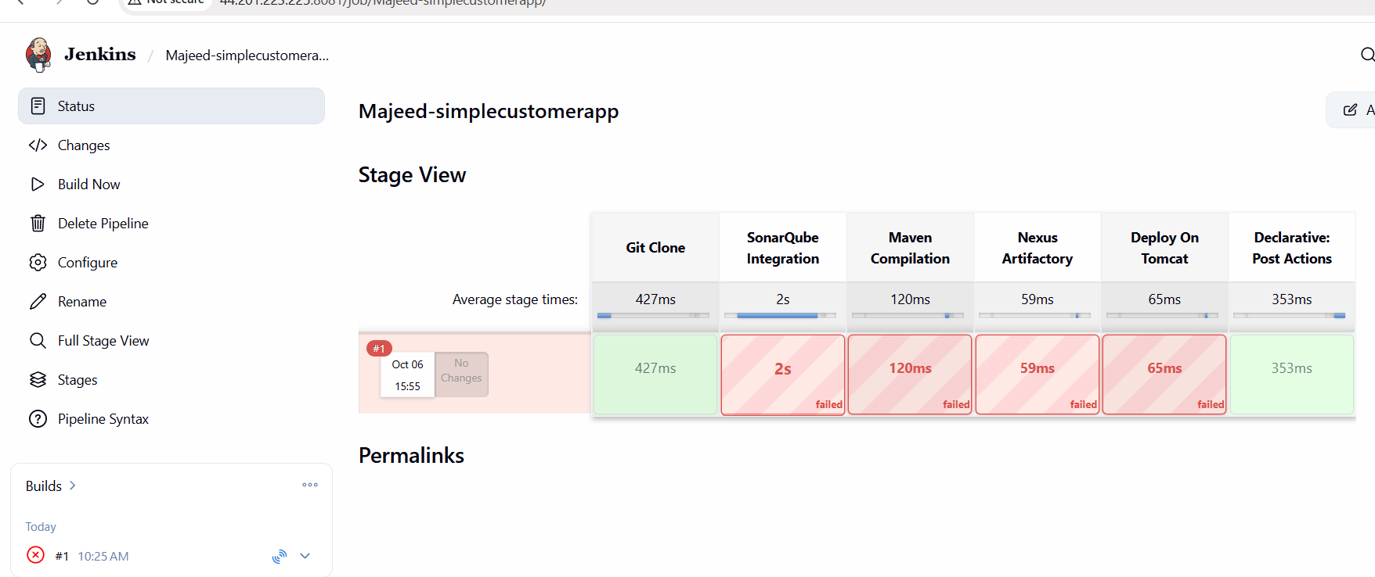
After this above error make changes in sonarqube script to this
So only replace the SonarQube stage with:
stage('SonarQube Integration') {
steps {
withSonarQubeEnv('sonarqube') {
sh 'mvn org.sonarsource.scanner.maven:sonar-maven-plugin:sonar'
}
}
}
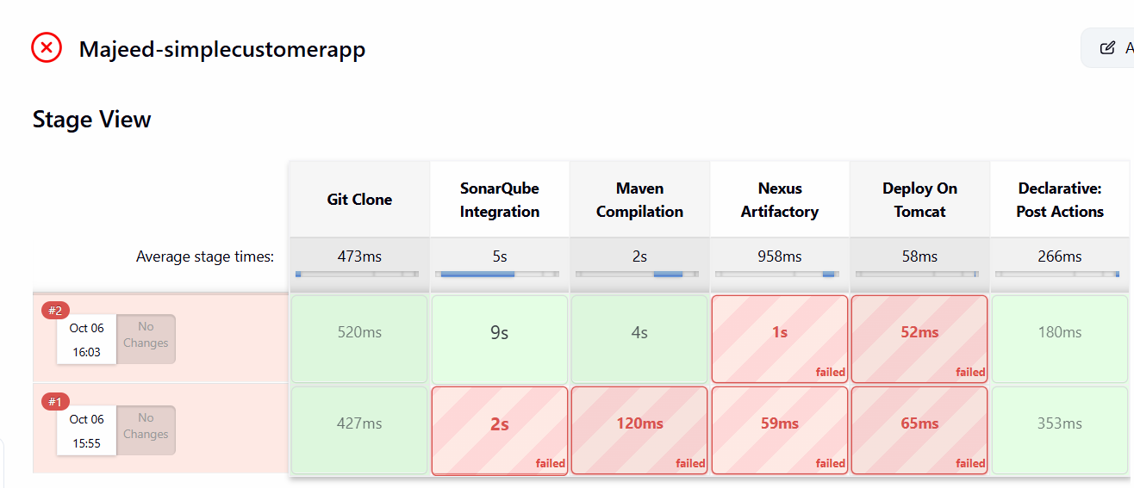
Sonarqube stage is passed and Maven stages passed again error in Nexus and deploy on tomcat failed- The failure is only in Nexus Artifactory.

Fix Stage 4
We should use the exact WAR filename generated by Maven.
Replace only the Nexus Artifactory stage with:
stage('Nexus Artifactory') {
steps {
withCredentials([usernamePassword(
credentialsId: 'nexus-credentials',
usernameVariable: 'NEXUS_USERNAME',
passwordVariable: 'NEXUS_PASSWORD'
)]) {
sh '''
mvn deploy:deploy-file \
-DgroupId=com.javatpoint \
-DartifactId=SimpleCustomerApp \
-Dversion=${BUILD_NUMBER} \
-Dpackaging=war \
-Dfile=target/SimpleCustomerApp-${BUILD_NUMBER}-SNAPSHOT.war \
-DrepositoryId=nexus \
-Durl=http://10.0.3.11:8081/repository/maven-releases-1/ \
-DgeneratePom=true \
-Dusername=$NEXUS_USERNAME \
-Dpassword=$NEXUS_PASSWORD
'''
}
}
}
After pasting above scipt for Nexus
Task 2 pipeline is completed
Your Declarative Jenkins pipeline now successfully performs:

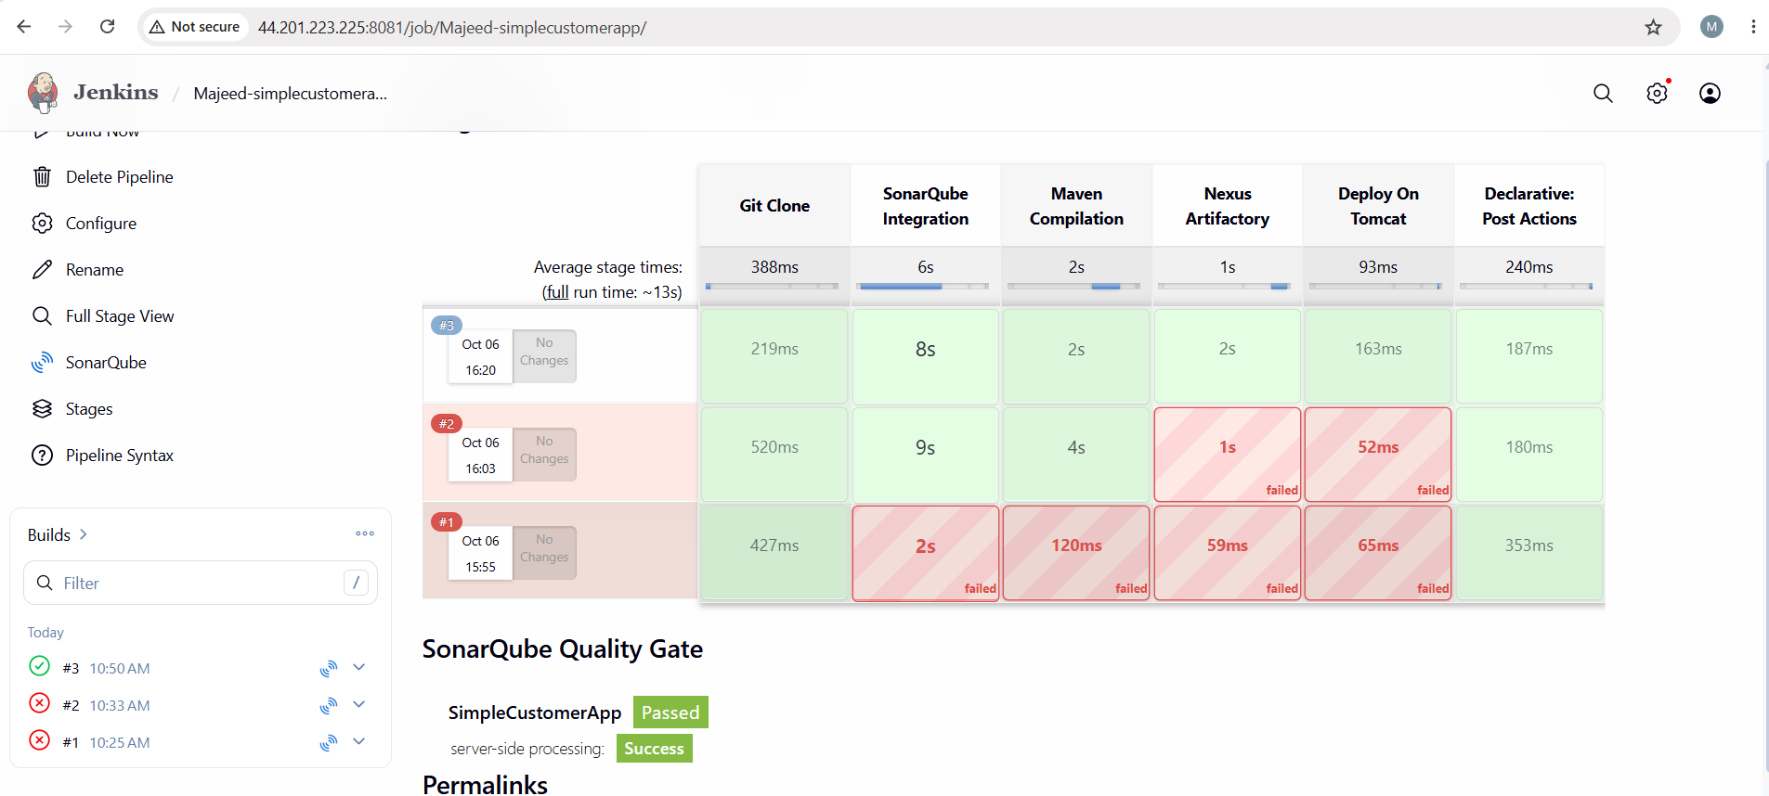
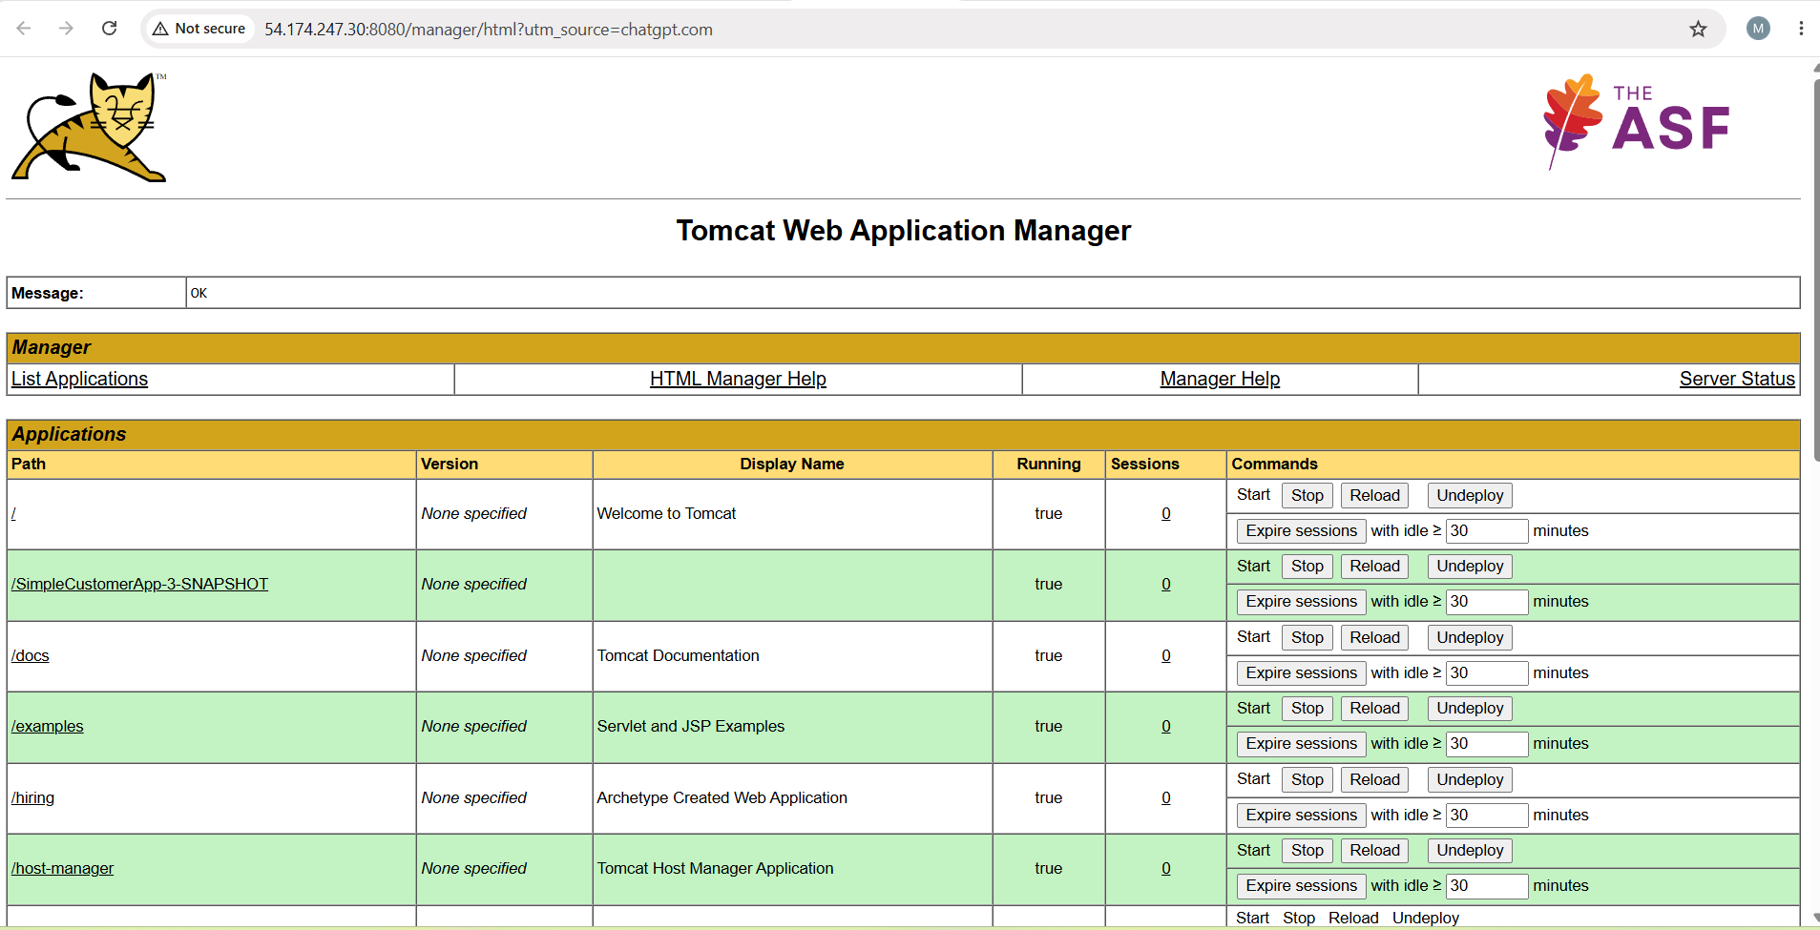
Yes. That means Tomcat itself is working. ✅
- Tomcat server: http://54.174.247.30:8080
- Tomcat Manager: http://54.174.247.30:8080/manager/html

Task 2 — Jenkins Declarative CI/CD Pipeline
1. Task Objective
Create a Jenkins Declarative Pipeline for the feature-1.1 branch.
GitHub Repository:
https://github.com/betawins/sabear_simplecutomerapp.git
Branch:
feature-1.1
2. Pipeline Stages
The pipeline contains:
- Git Clone
- SonarQube Integration
- Maven Compilation
- Nexus Artifactory
- Deploy On Tomcat
- Slack Notification

3. Jenkins Job
Job Name:
Majeed-simplecustomerapp
Job Type:
Pipeline
Definition:
Pipeline script
Groovy Sandbox:
Checked ✅

4. Infrastructure
Server | Private IP | Public IP | Purpose
Jenkins | 10.0.3.141 | 44.201.223.225 | CI/CD
SonarQube | 10.0.3.34 | 3.88.194.195 | Code Analysis
Nexus | 10.0.3.11 | 98.94.43.89 | Artifact Repository
Tomcat | 10.0.3.65 | 54.174.247.30 | Application Deployment

5. Important Jenkins Configuration
SonarQube
Jenkins:
Manage Jenkins → System → SonarQube installations
Configuration:
Name: sonarqube
Server URL: http://10.0.3.34:9000
The pipeline uses:
withSonarQubeEnv('sonarqube')
Important
The name sonarqube in the pipeline must exactly match the Jenkins SonarQube configuration name.

6. Nexus Credentials
Jenkins credential:
ID: nexus-credentials
Nexus repository:
http://10.0.3.11:8081/repository/maven-releases-1/
The credential is used by the pipeline with:
withCredentials([usernamePassword(
credentialsId: 'nexus-credentials',
usernameVariable: 'NEXUS_USERNAME',
passwordVariable: 'NEXUS_PASSWORD'
)])
Never put the actual Nexus password directly in the Jenkinsfile.

7. Tomcat Configuration
Tomcat server:
http://54.174.247.30:8080
Tomcat Manager:
http://54.174.247.30:8080/manager/html
Jenkins credential:
ID: tomcat-credentials
The Pipeline Syntax generator produced the Tomcat deployment step:
deploy adapters: [
tomcat9(
alternativeDeploymentContext: '',
credentialsId: 'tomcat-credentials',
path: '',
url: 'http://54.174.247.30:8080'
)
],
contextPath: null,
war: 'target/*.war'
Using Pipeline Syntax → Generate Pipeline Script is recommended because Jenkins generates the correct syntax for the installed plugin.

8. Final Jenkins Pipeline
pipeline {
agent any

stages {

stage('Git Clone') {
steps {
git branch: 'feature-1.1',
url: 'https://github.com/betawins/sabear_simplecutomerapp.git'
}
}

stage('SonarQube Integration') {
steps {
withSonarQubeEnv('sonarqube') {
sh 'mvn org.sonarsource.scanner.maven:sonar-maven-plugin:sonar'
}
}
}

stage('Maven Compilation') {
steps {
sh 'mvn clean package'
}
}

stage('Nexus Artifactory') {
steps {
withCredentials([usernamePassword(
credentialsId: 'nexus-credentials',
usernameVariable: 'NEXUS_USERNAME',
passwordVariable: 'NEXUS_PASSWORD'
)]) {
sh '''
mvn deploy:deploy-file \
-DgroupId=com.javatpoint \
-DartifactId=SimpleCustomerApp \
-Dversion=${BUILD_NUMBER} \
-Dpackaging=war \
-Dfile=target/SimpleCustomerApp-${BUILD_NUMBER}-SNAPSHOT.war \
-DrepositoryId=nexus \
-Durl=http://10.0.3.11:8081/repository/maven-releases-1/ \
-DgeneratePom=true \
-Dusername=$NEXUS_USERNAME \
-Dpassword=$NEXUS_PASSWORD
'''
}
}
}

stage('Deploy On Tomcat') {
steps {
deploy adapters: [
tomcat9(
alternativeDeploymentContext: '',
credentialsId: 'tomcat-credentials',
path: '',
url: 'http://54.174.247.30:8080'
)
],
contextPath: null,
war: 'target/*.war'
}
}

}

post {
success {
slackSend message: "Majeed-simplecustomerapp BUILD #${BUILD_NUMBER} SUCCESS"
}

failure {
slackSend message: "Majeed-simplecustomerapp BUILD #${BUILD_NUMBER} FAILED"
}
}
}

9. Build Result
Build #3 successfully completed the pipeline.
Stage | Result
Git Clone | ✅ SUCCESS
SonarQube Integration | ✅ SUCCESS
Maven Compilation | ✅ SUCCESS
Nexus Artifactory | ✅ SUCCESS
Deploy On Tomcat | ✅ SUCCESS
Slack Notification | ✅ SUCCESS
Final Flow
GitHub
↓
feature-1.1
↓
Jenkins
↓
SonarQube
↓
Maven Build
↓
Nexus
↓
Tomcat
↓
Slack Notification
Useful URLs
Jenkins:
http://44.201.223.225:8081
SonarQube:
http://3.88.194.195:9000
Nexus:
http://98.94.43.89:8081
Tomcat:
http://54.174.247.30:8080
Tomcat Manager:
http://54.174.247.30:8080/manager/html

Important Troubleshooting Learned
SonarQube error
If you see:
No plugin found for prefix 'sonar'
Use:
sh 'mvn org.sonarsource.scanner.maven:sonar-maven-plugin:sonar'
instead of:
sh 'mvn sonar:sonar'
Nexus error
If you see:
target/*.war not found
Don't use the wildcard for -Dfile.
Use:
target/SimpleCustomerApp-${BUILD_NUMBER}-SNAPSHOT.war
because Maven creates files such as:
target/SimpleCustomerApp-3-SNAPSHOT.war
Tomcat 404
If:
http://54.174.247.30:8080/
works but the application URL gives 404, check:
Tomcat Manager → Applications → Path
The application context may not be exactly /SimpleCustomerApp/.

